**CONTENTS AND STRUCTURE:**

**REFLECTION ON LEARNING:**

**The Support Vector Machine Algorithm**

Support Vector Machine Algorithm become widely adopted, mainly due to their ability to achieve sometimes more than 90% of correct answers or accuracy, for difficult problems.

SVMs are implemented in a unique way when compared to other machine learning algorithms, once they are based on statistical explanations of what learning is, or on Statistical Learning Theory

As a highly proficient supervised learning algorithm, Support Vector Machine Algorithm become widely adopted, mainly due to their ability to achieve sometimes more than 90% of correct answers or accuracy, for difficult problems.

SVMs are implemented in a unique way when compared to other machine learning algorithms, once they are based on statistical explanations of what learning is, or on Statistical Learning Theory

The basic intuition behind support vector machine is to find the best hyperplane for separating datasets in the feature space. For each image, we can interpret the image as a high dimensional vector where each pixel is one of our features. A support vector machine is attempting to find a hyperplane (classifying surface) that maximizes the distance (a more general term called margin) between the classes.

Support vector machines are very effective in scenarios where the number of features is greater than the number of samples like we often see in the image data case. Furthermore, support vector machine can be applied to more general solutions with non-linear boundaries by utilizing the kernel functions that exist with each support vector machine solver learning algorithm. This non-linearly aligns with piecewise approximations that denote complex, or complex data structures, in classification problems.

**Data Preparation Steps**

In preparing the CIFAR-10 dataset for SVM classification, the following steps were essential:

**1.Load Dataset**: To load the dataset, we utilized the CIFAR-10 dataset of **60,000** images and 10 classes. Loading it through the datasets module in TensorFlow made it easy.

**2.Visualize**: Visualizing the images helped me contextualize the data. For example, I could see how the classes (e.g. dogs and cats) differed in terms of color, shape, and background. This contextualized the classification.

**3.Grayscale and Flattening**: Converting the images to grayscale significantly reduced the data's dimensionality. Additionally, flattening the arrays of pixels converted the two-dimensional arrays into one-dimensional vectors to serve as input to the SVM.

**4.Split Dataset**: The dataset was split into train (50,000 images) and test (10,000 images) set to ensure the model was trained and evaluated on unseen data.

**5 Model Training and Evaluation:**For my training process I fitted the SVM classifier to the training set. I selected a linear kernel based on its simplicity and efficiency. Once the training was complete I assessed the classifier's performance on the test set using accuracy as the primary performance metric.

Despite the advantages of SVM I would run into performance issues regarding time and resources, especially as the CIFAR-10 dataset size increased. Optimizing SVM parameters like C (the regularization parameter) and the choice of kernel were helpful in improving SVM performance.

**Conclusions from Classifier Performance**

The SVM classifier achieved an accuracy of around 40% on the test set. Though rather limited, those errors provide us with an insight into the complexity of the CIFAR-10 dataset. The Classifier particularly struggled with classes that contained similar feature representations such as dogs and cats. Within classification, feature representations are very prevalent in discussion as they can have an influence on performance in similar contexts.

**RESPONSES TO LAB QUESTIONS:**

**COPY THIS IN CHATGPT AND FOLLOW THE FORMAT :**

visualize some images from the dataset.

Convert the images to grayscale and flatten them.

Split the dataset into training and testing sets.

Model Training:

Understand the concept of Support Vector Machine (SVM).

Train an SVM classifier using the training set.

Model Evaluation:

Make predictions on the testing set.

Evaluate the model's performance using accuracy.

Visualize some predictions along with their true lab

**INCORPORATION OF VISUAL AIDS:**

The following visuals are included to aid comprehension:

Example Images from CIFAR-10: The example images from various classes provided insight into the classification problem.

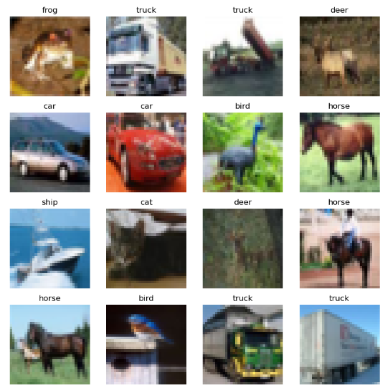

Confusion Matrix: This matrix illustrates the model's performance across classification classes and identifies which classes it misclassified the most often.

**CRITICAL ANALYSIS AND REFERENCING:**

.

